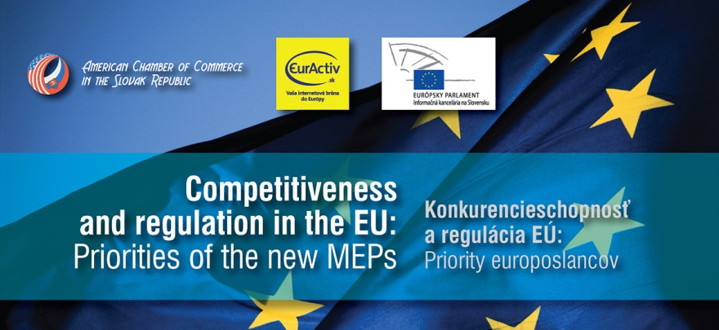
AmCham in cooperation with EurActiv.sk and Information Office of the European Parliament is happy to invite you to the first roundtable discussion and networking with newly elected Members of the European Parliament (MEPs)
on October 3, 2014 from 10:00 AM to 12:00 PM
at Sheraton Hotel, Bratislava

You have a unique opportunity to become a partner of this event!

M A I N P A R T N E R: 2,500 EUR
As the main partner, you will be integral in shaping the debate and discussing your priorities directly with the MEPs. As part of the benefits, you will be granted:
- VIP seat at the roundtable: You will be one of the direct discussion participants, seated at a table with the MEPs. This will enable you to raise points in the discussion and shape the nature of the discussion
- Invitation to VIP lunch: After the event, there will be a VIP lunch with the MEPs, which will be restricted to a small group of stakeholders, and you will be part of it!
- Promotion of your brand: Your company logo will be on all printed and electronic materials, invitations, banners, advertisements; You will be able to bring roll-up logos and PR materials and display them at the event
- Media campaign: Your company will be mentioned in all press releases about the event sent to major Slovak media as well as in all articles about the conference in the AmCham “Connection” magazine
- EurActiv campaign: Your company logo/ name will be displayed as part of the event in EurActiv.sk calendar of events, published on the EurActiv.sk website and your company will also be mentioned in the EurActiv.sk daily newsletter with 22,000 subscribers; You will also get an opportunity for opinions of your experts to be included in the articles featured on the EurActiv.sk news portal
P A R T N E R: 1,500 EUR
As a partner of the event, you will be guaranteed a seat in the audience, as well as these additional benefits:
- Invitation to VIP lunch: After the event, there will be a VIP lunch with the MEPs, which will be restricted to a small group of stakeholders.
- Promotion of your brand: Company logo on all printed and electronic materials, invitations, banners, advertisements; Roll-up logos and PR materials at the event
- Media campaign: Company mentioned in all press releases about the conference sent to major Slovak media; Company mentioned in all articles about the conference in the AmCham “Connection” magazine
- EurActiv campaign: Company logo/ name displayed as part of the event in EurActiv.sk calendar of events, published on the EurActiv.sk website and company name mentioned in the EurActiv.sk daily newsletter with 22,000 subscribers
S P E C I A L O P T I O N – J O I N T P A R T N E R S H I P
On November 21, 2014, AmCham in cooperation with EurActiv.sk and the Representation of the European Commission is preparing EU STAKEHOLDER BRUNCH with the Slovak Commissioner Maroš Šefčovič. The event will take place in KOŠICE. Special offer will be made to companies interested in becoming partners for both events. If you are interested, contact anna.michalkova@amcham.sk or jan.bodnar@amcham.sk
P A R T I C I P A N T
In case you would only like to participate in the event as a member of the audience, you can register at events@amcham.sk by October 1, 2014 at the latest.
The registration will be done on a first come, first served basis until the capacity is reached.

